Active Reports 14

**Pre-Requirements:**

* ActiveReports 14 requirements for use with .NET Full Framework:

**.NET Full Framework:** Desktop (WinForms, WPF), ASP.NET

**IDE:** Visual Studio 2019/2017/2015/2013

**Language:** Visual Basic, C#

**OS:** Windows 10/ 8.1, Windows Server 2019/2016/2012 R2/2012

**Framework**: .NET Framework 4.8/ 4.7.2/ 4.7.1/ 4.7/ 4.6.2

**Internet Information Services (IIS) -** 7, 7.5, 8, 8.5, 10

* ActiveReports 14 requirements for use with .NET Core:

**ASP.NET Core**

**IDE:** Visual Studio 2019/2017

**Language:** Visual Basic, C#

**OS:** Windows 10/ 8.1, Windows Server 2019/2016/2012 R2/2012

**Framework**: .NET Framework 4.8/ 4.7.2/ 4.7.1/ 4.7/ 4.6.2

**Internet Information Services (IIS) -** 7, 7.5, 8, 8.5, 10

* ActiveReports Web Designer Supported Environment

**Database Server:**

* SQL Server 2012/ 2014/2016
* Oracle 11g (Database Only) - 32bit & 64bit
* MySQL
* PostgreSQL

**Client (Browser):**

* + - Internet Explorer (v11)
    - Chrome (v50 and higher)
    - Firefox (v57 and higher)

Follow below link for more details on requirements:

<https://www.grapecity.com/activereports/docs/v14/online/requirements.html>

**Install Active Reports:**

Before you begin with the following steps, download the installer (ActiveReports-v14.x.x.0.msi) from the [website](https://www.grapecity.com/activereports) and follow these steps.

1. Double-click the ActiveReports-v14.x.x.0.msi file or right-click the file and select **Install**.
2. On the End-User License Agreement screen that appears, go through the terms in the License Agreement.
   * If you want to continue with the default installation settings, select the check box to accept the license agreement and click **Install** to continue with installation.
   * If you want to change the default installation path and the way product features are installed, do the following:

1. Select **Advanced** and click **Change**.

2. Specify the path for the installation and click OK.

3. Click **Next** and select how controls, features, and samples are installed and integrated with Visual Studio versions.

4. Select **Install**.

1. On the User Account Control screen, select Yes to allow ActiveReports software installation on your PC.
2. Once the installation finishes, a screen notifying the completion of installation appears. Select **Activate now** check box and click **Finish** to close the window and complete the installation process.
3. Click **Yes** on the User Account Control screen to continue with activating the license. See [License Your ActiveReports](https://www.grapecity.com/activereports/docs/v14/online/ar-how-licensing-activereports.html) for information on licensing.

### Installed Files:

You can verify the installation via installer by following the steps below:

1. Open Visual Studio.
2. From the Visual Studio **Help** menu, select **About Microsoft Visual Studio** and verify that **ActiveReports 14** appears in the installed products list.

Follow below link for more details on installation:

<https://www.grapecity.com/activereports/docs/v14/online/install-activereports.html>

**License Types of ActiveReports:**

See [ActiveReports Editions](https://www.grapecity.com/activereports/docs/v14/online/activereports-editions.html) to learn which features are exclusive to the Professional Edition.

|  |  |
| --- | --- |
| **License Type** | **Description** |
| Evaluation | **Trial key is required.** Evaluation banners display on all reports and controls, and the product stops functioning after 30 days from the date of installation. The first key is already activated when you download the trial. If needed, you can request a new key from the Sales department for an additional 30 day trial. |
| Standard | **Standard Edition product key is required.** Evaluation banners appear only on features that are exclusive to the Professional Edition. You receive this key by email when you purchase ActiveReports Standard Edition or upgrade from a previous version of ActiveReports Standard Edition. |
| Professional | **Professional Edition product key is required.** All reporting functionality and controls appear without any evaluation banners. You receive this key by email when you purchase ActiveReports Professional Edition or upgrade from a previous version of ActiveReports Professional Edition. |

If you cannot find your email with the product key, please contact [activereports.sales@grapecity.com](mailto:activereports.sales@grapecity.com) to have it looked up.

Follow below link for more details on licensing:

<https://www.grapecity.com/activereports/docs/v14/online/ar-how-licensing-activereports.html>

**Quick Start:**

Follow below link for more details on quick start:

<https://www.grapecity.com/activereports/docs/v14/online/quick-start.html>

**POC Implementation:**

1. **Migrate existing AR2 report to latest AR (RPX to RDLX)**

Created **RPX To RDLX .exe** which helps us to convert existing ActiveReports Section report(s) (rpx) to Page and RDL reports.

**Steps:**

1. Run the **RPX To RDLX .exe**

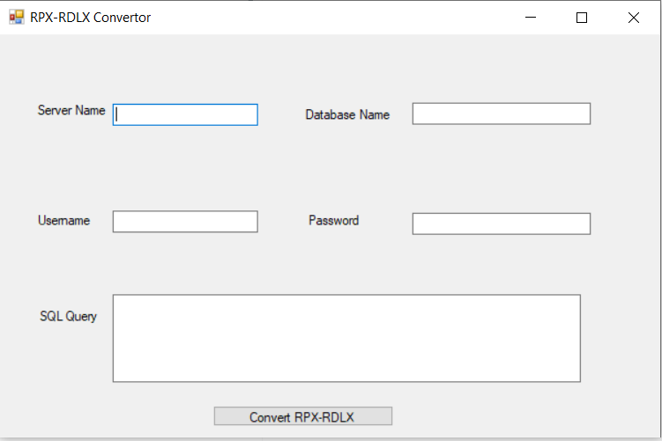

1. Provide all necessary details and then click on “Convert rpx-RDLX” button.
2. ActiveReports Import Wizard that appears, click **next**.

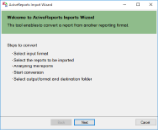

1. Choose **ActiveReports (rpx)** as the input format and click **next**.

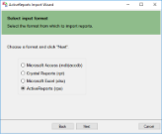

1. Click the ellipsis button to browse to the location that contains section report(s).
2. Select the reports to import and then click **next** to analyze them.

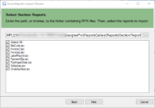

1. Specify the import options.

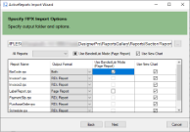

* 1. Use the ellipsis button to select a destination folder to store the converted reports.
  2. Select the output format of the reports.  
     From the drop-down, select output format as Page, RDL, or Both. If 'Both' is selected, then the converted Page and RDL reports are added with postfixes _page and _rdl, respectively in the destination folder.
  3. Select whether to use Banded List for Page report.  
     The option to select **Use Banded List Mode** is available if the output format of a report is Page report.
     + If you want all controls to be placed on one BandedList in the same way as in RDL report, you should use banded list mode. In this case, the Fixed size for Page report needs to be set manually.
     + If you want to convert a Section report that has only one section (that is detail), you should not use banded list mode. With 'Use Banded List Mode' not selected (default):
       - controls are not placed on BandedList
       - sections such as Report Header/Report Footer and Page Header/Page Footer are ignored
       - all converted controls are placed on one Page and treated as they have been on one section

The option to select **Use New Chart** lets you convert an existing chart to a new chart. By default, this option is selected; if unselected, the chart converts to classic chart.

1. Click **Next** to start the conversion.

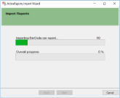

1. Once the conversion process is complete, click **Finish** to close the wizard and go the destination folder to view the converted reports. You may optionally leave the check on for the **Open Log file** checkbox to see the results log.

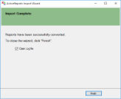

1. Select .rdlx folder.

***Important:***

* ***At conversion, any script from the script editor is ignored.***
* ***Manual efforts:***
  + ***Scripts will not work directly, so we need to change conditionally using report designer.***
  + ***Special functions like arithmetic operations need to be updated.***
  + ***Formatting properties (like MM/dd/yyyy, currency etc)***

Follow below link for more details on importing reports:

<https://www.grapecity.com/activereports/docs/v14/online/importing-reports.html>

1. **Migrate existing Custom report to latest AR (ERT to RDLX)**

Created **ERT to RDLX .exe** which helps us to convert existing ert to Page and RDL reports.

**Steps:**

* 1. Run the **ERT To RDLX .exe**

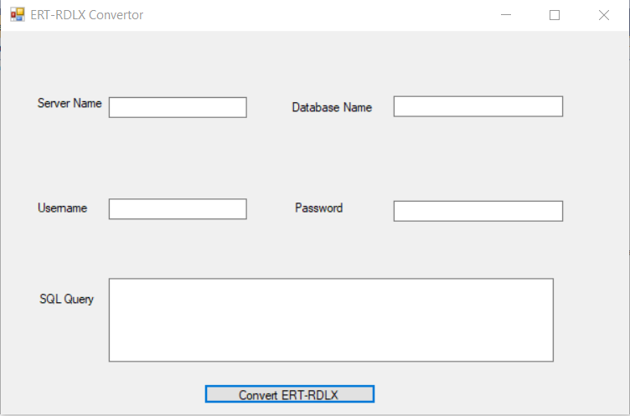

* 1. Provide all necessary details and then click on “Convert ERT-RDLX” button.
  2. Select .ert file from open file dialog box.(Internally Converts ert to rpx file)
  3. Select folder to save .rpx file from open file dialog box.
  4. Click on ok dialog box.
  5. ActiveReports Import Wizard that appears, click **next**.



* 1. Choose **ActiveReports (rpx)** as the input format and click **next**.
  2. Click the ellipsis button to browse to the location that contains section report(s).
  3. Select the reports to import and then click **next** to analyze them.



* 1. Specify the import options.



* 1. Use the ellipsis button to select a destination folder to store the converted reports.
  2. Select the output format of the reports.  
     From the drop-down, select output format as Page, RDL, or Both. If 'Both' is selected, then the converted Page and RDL reports are added with postfixes _page and _rdl, respectively in the destination folder.
  3. Select whether to use Banded List for Page report.  
     The option to select **Use Banded List Mode** is available if the output format of a report is Page report.
     + If you want all controls to be placed on one BandedList in the same way as in RDL report, you should use banded list mode. In this case, the Fixed size for Page report needs to be set manually.
     + If you want to convert a Section report that has only one section (that is detail), you should not use banded list mode. With 'Use Banded List Mode' not selected (default):
       - controls are not placed on BandedList
       - sections such as Report Header/Report Footer and Page Header/Page Footer are ignored
       - all converted controls are placed on one Page and treated as they have been on one section

The option to select **Use New Chart** lets you convert an existing chart to a new chart. By default, this option is selected; if unselected, the chart converts to classic chart.

* 1. Click **Next** to start the conversion.



* 1. Once the conversion process is complete, click **Finish** to close the wizard and go the destination folder to view the converted reports. You may optionally leave the check on for the **Open Log file** checkbox to see the results log.



* 1. Select .rdlx folder.

***Important:***

* ***At conversion, any script from the script editor is ignored.***
* ***Manual efforts:***
  + ***Scripts will not work directly, so we need to change conditionally using report designer.***
  + ***Special functions like arithmetic operations need to be updated.***
  + ***Formatting properties (like MM/dd/yyyy, currency etc)***

**References:**

1. <https://www.grapecity.com/activereports/docs/v14/online/overview.html>
2. <https://www.grapecity.com/videos/activereports>